

ASIC AND FPGA DESIGN
24EC2237F (Summer Term)

Course Coordinator:

Dr.B.BALAJI

STUDENT ID: ACADEMIC YEAR: 2025-26 STUDENT NAME:

Table of Contents

Session 01: Introductory Session NA

Session 02: Design Standard Cells Using Verilog Code 1

Session 03: Design 4-bit even parity generator and checker Logic using Verilog Code 7

Session 04: Write Verilog Code to implement 3-input combinational logic using 4x1 Multiplexer 13

Session 05: Write Verilog Code to implement 7-segment display 19

Session 06: Write Verilog Code to implement "D" and "T" flip-flop using "JK" flip-flop 25

Session 07: Design Macrocell for Given Boolean Function Using Verilog Code 31

Session 08: Design CLB for Given Truth Table Using Verilog Code 37

Session 09: Implement Moore Sequence Detector Using Verilog Code 43

Session 10: Implement Mealy Sequence generator Using Verilog Code 50

Session 11: Design Gated Clock 4-bit Up/down Synchronous and Asynchronous counter using Verilog Code 56

Session 12: Design 3-bit Random number generator using Verilog Code 62

Session 13: Implement SRAM using Verilog Code 68

A.Y. 2025-26 LAB CONTINUOUS EVALUATION

S.No | Date | Experiment Name | Pre- Lab (10M) | In-Lab (25M) |  |  | Post- Lab (10M) | Viva Voce (5M) | Total (50M) | Faculty Signature
 |  |  |  | Program/ Procedure (5M) | Data and Results (10M) | Analysis & Inference (10M)
1. |  | Introductory Session | -NA-
2. |  | Design Standard Cells Using Verilog  Code
3. |  | Design 4-bit even parity generator and  checker Logic using Verilog Code
4. |  | Write Verilog Code to implement 3- input combinational logic using 4x1  Multiplexer
5. |  | Write Verilog Code to implement 7-  segment display
6. |  | Write Verilog Code to implement "D"  and "T" flip-flop using "JK" flip-flop.
7. |  | Design Macrocell for Given Boolean  Function Using Verilog Code
8. |  | Design CLB for Given Truth Table Using  Verilog Code
9. |  | Implement Moore Sequence Detector  Using Verilog Code.
10. |  | Implement Mealy Sequence generator  Using Verilog Code.
11. |  | Design Gated Clock 4-bit Up/down Synchronous and Asynchronous  counter using Verilog Code
12 |  | Design 3-bit Random number generator  using Verilog Code

S.No | Date | Experiment Name | Pre- Lab (10M) | In-Lab (25M) |  |  | Post- Lab (10M) | Viva Voce (5M) | Total (50M) | Faculty Signature
 |  |  |  | Program/ Procedure (5M) | Data and Results (10M) | Analysis & Inference (10M)
13 |  | Implement SRAM using Verilog Code

Introductory Session
Xilinx Vivado is a powerful software tool suite for FPGA (Field-Programmable Gate Array) and SoC (System on Chip) design. Here's an introduction to Vivado in five key points:

FPGA Development: Vivado is primarily used for designing, programming, and debugging FPGAs, which are customizable hardware devices that can be reconfigured to perform various tasks. It supports a wide range of Xilinx FPGA families.

Hardware Description Language (HDL): Vivado allows designers to write and simulate their designs using hardware description languages like VHDL or Verilog. These languages describe the logical behavior of the hardware.

High-Level Synthesis (HLS): Vivado includes a high-level synthesis tool that enables designers to create FPGA designs from higher-level software code written in languages like C, C++, or OpenCL. This simplifies the design process for software engineers.

Integrated Development Environment (IDE): Vivado offers a comprehensive and user-friendly IDE that includes tools for design entry, simulation, synthesis, implementation, and debugging. It streamlines the entire FPGA development workflow.

Advanced Design Optimization: Vivado provides optimization features to enhance FPGA performance and reduce power consumption. It includes tools for place-and-route, timing analysis, and resource utilization to help achieve the desired design goals.

In summary, Xilinx Vivado is a versatile and integrated software suite for FPGA and SoC development, making it a valuable tool for engineers and developers working on digital hardware projects.

Programming and simulating with Xilinx Vivado involves several steps, from creating your design to testing and debugging it. Here's a general procedure for programming and simulating in Vivado:

Design Entry:

- Start by creating a new project in Vivado.
- Specify your target FPGA device and project settings.
- Enter your design using hardware description languages (HDL) like VHDL or Verilog. You can also use high-level synthesis (HLS) if you're working with C, C++, or OpenCL code.

Simulate Your Design:

- Before synthesis and implementation, it's a good practice to simulate your design to verify its functionality.
- Use Vivado's built-in simulator or an external simulator like ModelSim.
- Create testbench modules to provide input stimuli to your design and observe its output.

Synthesis:

- After successful simulation, you can proceed to synthesis.
- The synthesis process translates your HDL code into a netlist, which represents the logical structure of your design.

Implementation:

- Implement your design by placing and routing the logical elements of your design into the target FPGA device.
- This process involves mapping your design to the specific resources available on the FPGA, optimizing for performance and area, and generating configuration files.

Generate Programming File:

- After successful implementation, generate a programming file (e.g., bitstream) that can be used to configure the FPGA.
- This file contains the information needed to program the FPGA with your design.

Programming the FPGA:

- Use the generated programming file to configure the FPGA device. You can do this through a JTAG interface, flash memory, or other configuration methods supported by your FPGA board.

Testing and Debugging:

- Once the FPGA is programmed, test your design on the actual hardware.
- Use debug tools provided by Vivado, such as the Integrated Logic Analyzer (ILA), to analyze and troubleshoot your design's behavior.

Iterate and Optimize:

- If you encounter issues during testing, go back to the design entry, simulation, and synthesis stages to make necessary modifications.
- Optimize your design for performance, area, or power consumption as needed.

Documentation and Packaging:

- Document your design and the steps you've taken.
- Package your project files, including the bitstream file and necessary documentation, for future use or deployment.

Deployment:

- Deploy your FPGA-based solution in your target application, whether it's in an embedded system, data center, or any other environment where FPGA technology is used.

This procedure outlines the typical workflow when working with Xilinx Vivado. It's important to follow each step carefully and verify your design at each stage to ensure a successful FPGA development project.

Experiment Title: Design 4-bit even parity generator and checker Logic using Verilog Code
Aim/Objective:
The aim of this experiment is to Design 4-bit even parity generator and checker Logic using Verilog Code

Description:
A 4-bit even parity generator and checker logic is a digital circuit that is used to add a parity bit to a 4-bit binary data word and to check whether the received data with the parity bit has the correct even parity. Even parity means that the number of '1' bits in the data, including the parity bit, should be even. Here's a description of the design for a 4-bit even parity generator and checker:

Input:

Four data bits (D3, D2, D1, D0): These are the 4 bits of binary data that need to have even parity checked.
One parity bit (P): This is the parity bit added to the data.

Even Parity Generation:

To generate even parity, the logic checks the number of '1' bits in the data (D3, D2, D1, D0).
If the number of '1' bits is odd, the parity bit (P) is set to '1' to make the total number of '1' bits even. If the number of '1' bits is already even, the parity bit (P) is set to '0'.
Even Parity Checking:

To check even parity, the circuit counts the number of '1' bits in the received data (D3, D2, D1, D0) and the received parity bit (P).
If the total number of '1' bits, including the parity bit, is even, the data is considered error-free, and the parity checker indicates that the data is valid.
If the total number of '1' bits is odd, the checker indicates that a parity error has occurred, indicating that the data may be corrupted.

Operation:

The 4-bit data word (D3, D2, D1, D0) is input to both the even parity generator and checker. The generator calculates the even parity bit (P) and adds it to the data.
The generated 5-bit word (D3, D2, D1, D0, P) is transmitted.
The checker receives the 5-bit word and checks if the total number of '1' bits is even or odd.
Based on the parity check result, the checker may indicate a parity error or accept the data as valid. In summary, a 4-bit even parity generator and checker ensures that binary data has even parity by adding a parity bit, and it can check if the received data with the parity bit maintains even parity. This provides a basic form of error detection in digital communication systems.

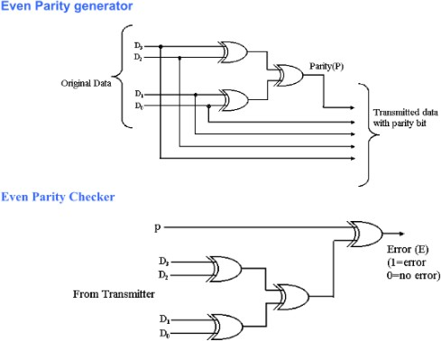

Pre-Requisites:
Xilinx-Vivado

Pre-Lab:
- What is parity, and why is it used in digital data transmission?

- Explain the concept of even parity and odd parity. How do they differ, and when would you use one over the other?

- How does an even parity generator work? Describe the logic involved in adding an even parity bit to a data word.

- How does an even parity checker work? What does it do to verify the correctness of data with the parity bit?

- If you have a 4-bit data word '1101,' what would be the even parity bit added to it? Explain the calculation.

In-Lab:
Design the parity generator and checker circuit using Verilog HDL.

See the RTL view and understand the logic.

Write test bench and simulate for different inputs and output responses.

Sample VIVA-VOCE Questions (In-Lab):
- What is the primary purpose of an even parity generator in digital communication?
  - To add 1's to the data to make the total number of 1's even
  - To add 0's to the data to make the total number of 1's even
  - To perform error detection in the received data
  - To correct errors in the received data

- In an even parity generator, if the data has an even number of 1's, what is the generated parity bit?
  - 0
  - 1
  - The parity bit remains 0
  - The parity bit remains

- What is the primary function of an even parity checker?
  - To generate a parity bit for received data
  - To ensure the received data has even parity
  - To convert data to its binary representation
  - To correct errors in the received data

- If the received data in an even parity checker has an even number of 1's, what does it indicate about the data's integrity?
  - The data is error-free.
  - The data has an error.
  - The parity checker will automatically correct any errors.
  - The data's integrity cannot be determined from the parity bit.

- In even parity, what will happen if a single bit error occurs during transmission?
  - The error will be corrected automatically.
  - The error will be detected, but not corrected.
  - The error will not be detected.
  - The error will cause the system to crash.

Post-Lab:
Record the hardware utilised and use any optimization techniques possible.

Record Power dissipation for different technology methods.

Record timing analysis for different technology methods.

Evaluator Remark (if Any): | Marks Secured out of 50
 | Signature of the Evaluator with Date
Evaluator MUST ask Viva-voce prior to signing and posting marks for each experiment.

Experiment Title: Write Verilog Code to implement 3-input combinational logic using 4x1 Multiplexer
Aim/Objective:
The aim of this experiment is to Write Verilog Code to implement 3-input combinational logic using 4x1 Multiplexer

Description:
A 4x1 multiplexer is a digital combinational logic circuit that selects one of four data inputs and forwards it to the output based on the values of the control inputs. It is a fundamental building block in digital electronics and is often used in various applications. Here's a description of a 4x1 multiplexer:

Components of a 4x1 Multiplexer:
- Data Inputs (D0, D1, D2, D3): A 4x1 multiplexer has four data inputs where you can connect different binary data values.
- Control Inputs (S1, S0): The multiplexer has two control inputs that determine which data input is selected. The number of control inputs (n) determines the number of data inputs (2^n). In this case, with two control inputs (S1 and S0), you can select one of four data inputs (2^2 = 4).
- Output (Y): The output of the multiplexer is the data value selected based on the control inputs.

Operation:
The control inputs (S1 and S0) allow you to choose one of the data inputs (D0, D1, D2, D3) to be passed to the output (Y). The binary values on S1 and S0 determine which input is selected. Here's how it works:
- When S1 and S0 are both '00,' D0 is selected, and the value on D0 is passed to the output Y.
- When S1 and S0 are '01,' D1 is selected, and the value on D1 is passed to the output Y.
- When S1 and S0 are '10,' D2 is selected, and the value on D2 is passed to the output Y.
- When S1 and S0 are '11,' D3 is selected, and the value on D3 is passed to the output Y.
Applications:
- Data Routing: Multiplexers are used in digital systems to route data from multiple sources to a single destination.
- Memory Addressing: In memory systems, multiplexers are used to select specific memory locations or registers based on the address provided.
- ALU (Arithmetic Logic Unit): In the CPU, multiplexers are used to select various data sources and operations during arithmetic and logic operations.
- Data Compression: In data compression algorithms, multiplexers are used to select between different compression or encoding schemes.

- Control Logic: Multiplexers are used in control circuits to select between different control signals based on the current state of the system.
- Demultiplexing: Multiplexers can be used in reverse as demultiplexers to distribute data from a single source to multiple destinations.
Overall, a 4x1 multiplexer is a versatile component that plays a crucial role in data selection and routing in digital systems, making it an essential building block in various digital applications.

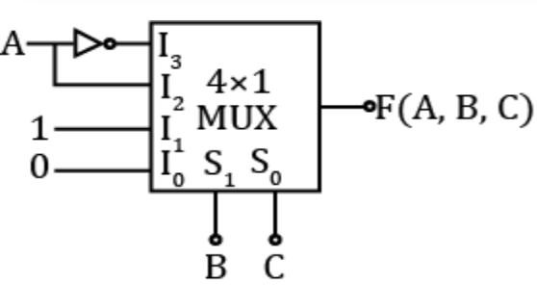

Pre-Requisites:
Xilinx-Vivado

Pre-Lab:
- What is the primary purpose of a multiplexer in digital circuits?

- How does a 2x1 multiplexer differ from a 4x1 multiplexer in terms of input and output lines?

- What is the role of select lines in a multiplexer, and how do they affect the output?

- Can you explain the concept of data selection and data routing using a multiplexer?

- In what situations or applications are multiplexers commonly used in electronics and digital systems?

In-Lab:
Design the parity generator and checker circuit using Verilog HDL.

See the RTL view and understand the logic.

Write test bench and simulate for different inputs and output responses.

Sample VIVA-VOCE Questions (In-Lab):
- What is the primary function of a multiplexer?
  - To perform addition of data
  - To combine multiple input signals into one output
  - To store data temporarily
  - To perform logical OR operation

- How many select lines are required for an n-to-1 multiplexer?
  - n
  - n - 1
  - log2(n)
  - 2^n

- In a 4-to-1 multiplexer, how many data input lines are there?
a) 1
b) 2
c) 3
d) 4

- What is the output of a multiplexer when all select lines are set to 0 (S0 = 0, S1 = 0, S2 = 0)?
  - The first input is selected.
  - The second input is selected.
  - The third input is selected.
  - The last input is selected.

- Which type of multiplexer is used to implement functions with multiple variables?
  - 2-to-1 multiplexer
  - 4-to-1 multiplexer
  - 8-to-1 multiplexer
  - 16-to-1 multiplexer

Post-Lab:
Record the hardware utilised and use any optimization techniques possible.

Record Power dissipation for different technology methods.

Record timing analysis for different technology methods.

Evaluator Remark (if Any): | Marks Secured out of 50
 | Signature of the Evaluator with Date
Evaluator MUST ask Viva-voce prior to signing and posting marks for each experiment.

Experiment Title: Write Verilog Code to implement 7-segment display
Aim/Objective:
The aim of this experiment is to Write Verilog Code to implement 7-segment display

Description:
A 7-segment display is a commonly used electronic display device that can show decimal numbers and a limited set of alphanumeric characters. It is made up of seven individual light-emitting diodes (LEDs) or other display technologies arranged in a specific pattern to represent numerical digits and a few letters. Here's a detailed description of a 7-segment display:

Components of a 7-Segment Display:
- Seven Segments: The core feature of a 7-segment display is the seven individual segments that form a digit. These segments are usually labeled a, b, c, d, e, f, and g.
- Common Anode or Common Cathode: 7-segment displays can be of two types: common anode or common cathode. In a common anode display, all the anodes of the seven LEDs are connected together and share a common positive voltage. In a common cathode display, the cathodes are connected together and share a common ground.
- Decimal Point (optional): Many 7-segment displays also include an eighth segment for displaying a decimal point.
Operation:
Each of the seven segments in a 7-segment display can be individually controlled to either illuminate or remain off. By selectively turning on or off these segments, you can create a representation of numerical digits (0-9) and a few letters (such as A, b, C, d, E, F, etc.) on the display. For example:
- To display the number '0,' you would illuminate segments a, b, c, d, e, f, while keeping segment g turned off.
- To display '1,' only segments b and c would be lit.
- To display 'A,' segments a, b, c, e, f would be illuminated, and the rest would be off.
The arrangement of segments in a 7-segment display is such that you can create all ten decimal digits and a few alphanumeric characters by controlling the individual segments. It's a simple and effective way to display numbers and basic characters in a compact format.
Applications:
- Digital Displays: 7-segment displays are widely used for displaying numerical information in digital devices such as digital clocks, calculators, and digital meters.
- Counters and Timers: They are commonly used in applications that require counting or timing functions.
- Appliances: Microwave ovens, ovens, and other household appliances use 7-segment displays to show the time, temperature, and cooking duration.
- Instrumentation: In scientific and industrial instruments, 7-segment displays are used to display measurements and readings.

- Scoreboards: In sports arenas, scoreboards use large 7-segment displays to show the score and game time.
- Traffic Signals: Some traffic signals use 7-segment displays to indicate the time remaining for a green or red light.
- Retail Price Displays: They are used in price displays in retail settings.

7-segment displays are known for their simplicity, low power consumption, and ease of use in various applications where basic numerical or alphanumeric information needs to be displayed. They come in different sizes, colors, and styles, depending on the application and design requirements.
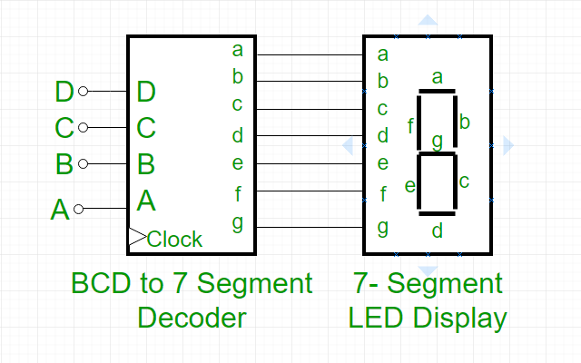

Pre-Requisites:
Xilinx-Vivado

Pre-Lab:
- What is a 7-segment display, and how does it visually represent numbers and characters?

- How many segments are there in a typical 7-segment display, and what is the purpose of each segment?

- What are common applications for 7-segment displays in everyday electronic devices?

- How are 7-segment displays controlled to show specific numbers or characters, and what is the role of multiplexing in this process?

- Can you explain the difference between common anode and common cathode 7-segment displays, and when each type is used?

In-Lab:
Design the parity generator and checker circuit using Verilog HDL.

See the RTL view and understand the logic.

Write test bench and simulate for different inputs and output responses.

Sample VIVA-VOCE Questions (In-Lab):
- What is the most common purpose of a 7-segment display?
  - To display text and images
  - To display numerical digits
  - To emit light for decoration
  - To store digital data

- How many segments are typically found in a 7-segment display?
a) 6
b) 7
c) 8
d) 9

- Which of the following is a commonly used configuration for driving a 7-segment display?
  - Common anode
  - Common cathode
  - Common ground
  - Common voltage

- What is the basic principle behind a 7-segment display's operation?
  - Each segment is individually controlled.
  - All segments are always on simultaneously.
  - The display relies on a mechanical mechanism.
  - It emits random patterns of light.

- Which digit can be displayed by lighting all seven segments in a 7-segment display?
a) 0
b) 7
c) 8
d) 9

Post-Lab:
Record the hardware utilised and use any optimization techniques possible.

Record Power dissipation for different technology methods.

Record timing analysis for different technology methods.

Evaluator Remark (if Any): | Marks Secured out of 50
 | Signature of the Evaluator with Date
Evaluator MUST ask Viva-voce prior to signing and posting marks for each experiment.

Experiment Title: Write Verilog Code to implement "D" and "T" flip-flop using "JK" flip-flop.
Aim/Objective:
The aim of this experiment is to Write Verilog Code to implement "D" and "T" flip-flop using "JK" flip- flop.

Description:
Flip-flops are fundamental building blocks in digital electronics and sequential logic circuits. They are bistable multivibrators, meaning they have two stable states and can store a single bit of information (either 0 or 1) for use in sequential logic and memory elements. Flip-flops are widely used in various digital systems and play a crucial role in data storage, synchronization, and control. Here's a detailed description of flip-flops:

Key Characteristics and Features of Flip-Flops:
- Bistable Operation: Flip-flops have two stable states, typically labeled as "0" and "1." They can hold their state until an external signal is applied to change their state.
- Clock Input (Clock Edge-Triggered): Most flip-flops have a clock input (e.g., rising-edge triggered or falling-edge triggered) that determines when data is transferred into or out of the flip-flop. The clock edge is used to synchronize the operation of the flip-flop with other elements in the circuit.
- Data Inputs (D and Other Inputs): Flip-flops have one or more data inputs, depending on the specific type of flip-flop. For example, a D flip-flop has a single data input (D), while a JK flip- flop has J and K inputs. The data input(s) control the state transition.
- Output(s): Flip-flops typically have one or more output signals that represent the current state of the flip-flop. The outputs reflect the stored bit of information.
- Clear and Preset Inputs (Optional): Some flip-flops have clear (CLR) and preset (PR) inputs that allow you to force the flip-flop into a specific state.

Common Types of Flip-Flops:
- D Flip-Flop: The D flip-flop stores the value on its data input (D) and transfers it to the output on a clock edge.
- SR Flip-Flop (Set-Reset Flip-Flop): The SR flip-flop has two inputs, S (Set) and R (Reset), which can set and reset the flip-flop's state.
- JK Flip-Flop: The JK flip-flop has J and K inputs that offer more versatile functionality compared to D and SR flip-flops. It can toggle, set, reset, or maintain its state based on the inputs.
- T Flip-Flop (Toggle Flip-Flop): The T flip-flop toggles its state when a clock pulse is applied if the T input is set (T=1).
- Master-Slave Flip-Flop: This is a combination of two flip-flops: a master and a slave. It is used to improve the stability of sequential circuits.

Applications:
- Data Storage: Flip-flops are used in registers, memory elements, and data storage devices to store and retrieve data.
- Clock Synchronization: They are essential for synchronizing the operation of different parts of a digital system with a common clock signal.
- State Machines: Flip-flops are used to implement state machines that control sequential operations in various applications.
- Digital Counters: They are used in digital counters to store and manipulate the count values.
- Digital Logic and Arithmetic Units: Flip-flops are used in digital arithmetic units and logic circuits for temporary data storage.
- Control Logic: They play a critical role in controlling the operation of digital systems by storing and latching control signals.

Flip-flops are fundamental components in digital circuits, and understanding their operation and characteristics is essential for designing and working with sequential logic systems. Different types of flip-flops offer varying levels of functionality and versatility, making them suitable for a wide range of applications in digital electronics.
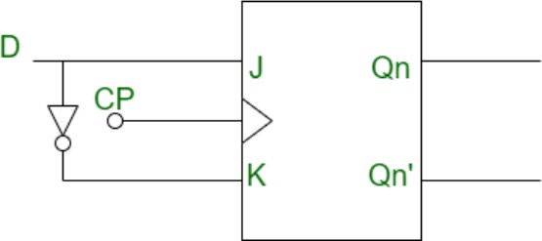

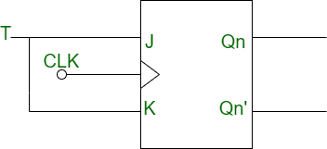

Pre-Requisites:
Xilinx-Vivado

Pre-Lab:
- What is a flip-flop in digital electronics, and how does it differ from other basic logic gates?

- What are the primary types of flip-flops, and what are their specific characteristics and applications?

- How does a D flip-flop differ from a JK flip-flop, and what are their respective functions?

- Explain the concept of clocking in flip-flops and its significance in sequential digital circuits.

- In what applications are flip-flops commonly used, and how do they contribute to the storage and processing of digital data in electronic systems?

In-Lab:
Design the parity generator and checker circuit using Verilog HDL.

See the RTL view and understand the logic.

Write test bench and simulate for different inputs and output responses.

Sample VIVA-VOCE Questions (In-Lab):
- What is the primary function of a flip-flop in digital circuits?
  - To perform arithmetic operations
  - To amplify input signals
  - To store and control binary information
  - To generate clock signals

- Which type of flip-flop has a clock input and two complementary outputs, Q and Q'?
  - D flip-flop
  - T flip-flop
  - SR flip-flop
  - JK flip-flop

- What does the "edge-triggered" property of flip-flops refer to?
  - The flip-flop's ability to operate at high clock speeds
  - The flip-flop's sensitivity to the input voltage levels
  - The flip-flop's response to the rising or falling edge of a clock signal
  - The flip-flop's ability to store multiple bits of data

- In a D flip-flop, what happens when the D input is set to 1 and the clock signal transitions from low to high (rising edge)?
  - The Q output becomes 1.
  - The Q output becomes 0.
  - The output does not change.
  - The flip-flop enters an undefined state.

- Which of the following flip-flops is known for its ability to toggle its output when both J and K inputs are set to 1?
  - D flip-flop
  - T flip-flop
  - SR flip-flop
  - JK flip-flop

Post-Lab:
Record the hardware utilised and use any optimization techniques possible.

Record Power dissipation for different technology methods.

Record timing analysis for different technology methods.

Evaluator Remark (if Any): | Marks Secured out of 50
 | Signature of the Evaluator with Date
Evaluator MUST ask Viva-voce prior to signing and posting marks for each experiment.

Experiment Title: Design Macrocell for Given Boolean Function Using Verilog Code

Aim/Objective:
The aim of this experiment is to Design Macrocell for Given Boolean Function Using Verilog Code

Description:
A macrocell is a key building block in complex programmable logic devices (CPLDs) and field- programmable gate arrays (FPGAs). It is a configurable logic block that provides a flexible combination of digital logic elements, flip-flops, and routing resources. Macrocells can be programmed to implement various digital functions and are a fundamental part of modern digital design. Here's a detailed description of macrocells:

Key Characteristics and Features of Macrocells:
- Configurable Logic: The primary purpose of a macrocell is to provide configurable logic resources. It typically includes lookup tables (LUTs) or other logic elements that can be programmed to implement a wide range of combinational functions.
- Flip-Flops: Macrocells often contain flip-flops or registers, which are used to store and control the sequencing of data. These flip-flops are frequently used for creating sequential logic elements.
- I/O and Multiplexers: Macrocells are typically equipped with input and output multiplexers that allow the connection of external signals to the logic resources within the macrocell. This enables interaction with other parts of the FPGA or CPLD.
- Routing Resources: Macrocells have access to routing resources that facilitate connections to other macrocells, I/O pins, and other parts of the FPGA. These resources enable flexible interconnection and data flow.
- Clock and Reset Control: Many macrocells have features for clock domain control and reset logic, allowing for synchronization and reset operations within the device.
- Cascade Capabilities: Some macrocells can be cascaded, allowing one macrocell's output to feed into another, which enables the creation of larger, more complex logic functions.
- Multiple Output Modes: Macrocells often support various output modes, including registered (synchronous) and combinatorial (asynchronous) outputs, giving flexibility in terms of signal timing.

Programming and Configuration:

The configuration of a macrocell is typically done using hardware description languages (HDL) or specialized design software provided by FPGA or CPLD vendors. You define the desired logic functions, connections, and sequential operations using these tools, and then the design is compiled into a configuration file that programs the FPGA or CPLD.

Applications:

- Digital Logic Design: Macrocells are used in a wide range of digital design applications, including implementing complex logical functions, counters, registers, state machines, and more.
- Control and Processing: They play a critical role in controlling digital systems, processing data, and executing algorithms in various applications, including embedded systems and signal processing.
- Custom Hardware Accelerators: In many high-performance applications, designers use macrocells to create custom hardware accelerators for specific tasks, enhancing system performance.
- Signal Processing: In DSP (Digital Signal Processing) applications, macrocells can be configured to implement specialized signal processing functions efficiently.
- Communication Protocols: Macrocells are essential for implementing complex communication protocols, such as Ethernet, USB, and wireless standards.
- Custom I/O Interfaces: They can be used to create custom input and output interfaces for connecting with other digital or analog systems.

In summary, macrocells are versatile and highly configurable building blocks found in CPLDs and FPGAs. They provide designers with the flexibility to create a wide range of digital logic functions, making them an essential component in modern digital design and enabling the development of custom hardware solutions for various applications.

Pre-Requisites:
Xilinx-Vivado

Pre-Lab:
- What is a Complex Programmable Logic Device (CPLD), and how does it differ from other programmable logic devices like FPGAs?

- What is the primary function of a macrocell within a CPLD, and how does it contribute to the device's programmability?

- How do macrocells in CPLDs enable the implementation of combinatorial and sequential logic functions in digital circuits?

- Can you explain the concept of register-based and multiplexer-based macrocells and their respective advantages and use cases?

- In what applications are CPLDs with macrocells commonly used, and how do they benefit the design and implementation of digital systems?

In-Lab:
Design the parity generator and checker circuit using Verilog HDL.

See the RTL view and understand the logic.

Write test bench and simulate for different inputs and output responses.

Sample VIVA-VOCE Questions (In-Lab):
- What is a macrocell in the context of programmable logic devices?
  - A small integrated circuit used for microcontroller applications
  - A programmable logic unit with a fixed function
  - A configurable logic element in a programmable logic device
  - A memory cell in a digital computer

- What is the primary function of a macrocell in a programmable logic device?
  - To generate clock signals
  - To store configuration data
  - To implement custom combinational and sequential logic functions
  - To perform arithmetic operations

- In a programmable logic device, what role do macrocells play in terms of customization?
  - They cannot be customized and have fixed functions.
  - They can only be customized with software updates.
  - They can be configured to implement a wide range of user-defined logic functions.
  - They can be reprogrammed to perform different arithmetic operations.

- Which of the following is an example of a programmable logic device that uses macrocells?
  - Microcontroller
  - Field-Programmable Gate Array (FPGA)
  - Static Random-Access Memory (SRAM)
  - Central Processing Unit (CPU)

- How does the configuration of macrocells in an FPGA typically take place?
  - By soldering connections on the FPGA
  - Through firmware updates
  - Using hardware description languages and synthesis tools
  - Automatically, without user intervention

Post-Lab:
Record the hardware utilised and use any optimization techniques possible.

Record Power dissipation for different technology methods.

Record timing analysis for different technology methods.

Evaluator Remark (if Any): | Marks Secured out of 50
 | Signature of the Evaluator with Date
Evaluator MUST ask Viva-voce prior to signing and posting marks for each experiment.

Experiment Title: Design CLB for Given Truth Table Using Verilog Code
Aim/Objective:
The aim of this experiment is to Design CLB for Given Truth Table Using Verilog Code

Description:
A Configurable Logic Block (CLB) is a fundamental building block in complex programmable logic devices (CPLDs) and field-programmable gate arrays (FPGAs). CLBs are highly configurable and provide a flexible array of digital logic resources, such as lookup tables (LUTs), flip-flops, and multiplexers, which can be programmed to implement a wide range of digital logic functions. Here's a detailed description of CLBs:

Key Characteristics and Features of CLBs:
- Lookup Tables (LUTs): CLBs typically contain one or more LUTs, which are programmable logic elements capable of implementing various combinational logic functions. A LUT can be configured to represent any Boolean function.
- Flip-Flops (Registers): CLBs often include flip-flops (registers) for sequential logic operations. These registers can store data, create clocked logic functions, and facilitate state machines and sequential operations.
- Multiplexers: CLBs may have multiplexers that allow you to select between various input signals for use in the logic functions. Multiplexers enable the dynamic configuration of data paths within the CLB.
- Carry Chains: In some advanced FPGAs, CLBs are equipped with carry chains that help facilitate arithmetic operations like addition and subtraction.
- Routing Resources: CLBs have access to routing resources that allow signals to be connected within the CLB and with neighboring CLBs, I/O pins, and other elements of the FPGA or CPLD.
- Cascade Capabilities: Many CLBs can be cascaded together, allowing outputs from one CLB to feed into another, enabling the creation of larger, more complex logical functions.
- Input/Output Pins: CLBs have input and output pins that allow connections to external signals and enable interaction with the rest of the digital system.
- Clock and Reset Control: Some CLBs include features for clock domain control and reset logic, aiding synchronization and reset operations within the FPGA.

Programming and Configuration:

The configuration of CLBs is typically performed using hardware description languages (HDL), such as VHDL or Verilog, or through specialized design software provided by FPGA or CPLD vendors. Designers specify the desired logic functions, connections, and sequential operations using these tools. The design is then compiled into a configuration file that programs the FPGA or CPLD.

Applications:
- Digital Logic Design: CLBs are a crucial element in digital logic design, enabling designers to implement a wide range of complex logical functions, including data processing, signal conditioning, state machines, and more.
- Custom Hardware Accelerators: In high-performance applications, CLBs can be used to create custom hardware accelerators tailored to specific tasks, improving system performance.
- Digital Signal Processing (DSP): CLBs can be programmed to perform specialized signal processing tasks, such as filtering, transformations, and encoding/decoding.
- Communication Protocols: CLBs are used to implement complex communication protocols, such as Ethernet, USB, and wireless standards, where flexibility in adapting to different protocols is essential.
- Custom Interfaces: Designers can use CLBs to create custom input and output interfaces, allowing FPGAs to connect with other digital or analog systems.

In summary, Configurable Logic Blocks (CLBs) are the heart of modern FPGAs and CPLDs, providing a versatile and flexible platform for implementing digital logic functions. Their configurability makes them suitable for a wide range of applications, from general-purpose digital logic design to highly specialized tasks in fields like signal processing and communication.
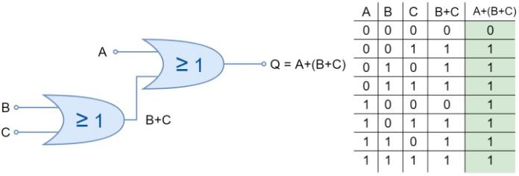

Pre-Requisites:
Xilinx-Vivado

Pre-Lab:
- What is an FPGA (Field-Programmable Gate Array), and how does it differ from other programmable devices like microcontrollers and CPLDs?

- What is the role of Configurable Logic Blocks (CLBs) within an FPGA, and how do they contribute to the device's flexibility and programmability?

- How are CLBs structured, and what types of logic functions can be implemented within them?

- Can you explain the concept of Look-Up Tables (LUTs) and how they are used in CLBs to configure logic functions?

- In what applications are FPGAs with CLBs commonly used, and what advantages do they offer in terms of digital system design and prototyping?

In-Lab:
Design the parity generator and checker circuit using Verilog HDL.

See the RTL view and understand the logic.

Write test bench and simulate for different inputs and output responses.

Sample VIVA-VOCE Questions (In-Lab):
- What is the primary function of a Configurable Logic Block (CLB) in a programmable logic device (PLD)?
  - To store data temporarily
  - To perform arithmetic operations
  - To implement custom combinational and sequential logic functions
  - To generate clock signals

- Which of the following is a common feature of CLBs in Field-Programmable Gate Arrays (FPGAs)?
  - Fixed logic functions that cannot be modified
  - The ability to store and execute software programs
  - Configurability to create custom logic functions
  - A built-in digital-to-analog converter (DAC)

- How are CLBs typically configured in FPGAs to implement custom logic functions?
  - By soldering connections on the FPGA
  - Through firmware updates
  - Using hardware description languages and synthesis tools
  - By replacing the entire FPGA chip

- In an FPGA, what is the purpose of interconnecting multiple CLBs with programmable routing resources?
  - To generate clock signals
  - To implement microcontroller functions
  - To create complex custom digital circuits
  - To store configuration data

- What distinguishes CLBs from standard logic gates or fixed-function logic elements?
  - CLBs are not used in digital systems.
  - CLBs are used for memory storage only.
  - CLBs offer configurable logic elements for custom functions.
  - CLBs are not found in Field-Programmable Gate Arrays (FPGAs).

Post-Lab:
Record the hardware utilised and use any optimization techniques possible.

Record Power dissipation for different technology methods.

Record timing analysis for different technology methods.

Evaluator Remark (if Any): | Marks Secured out of 50
 | Signature of the Evaluator with Date
Evaluator MUST ask Viva-voce prior to signing and posting marks for each experiment.

Experiment Title: Implement Moore Sequence Detector Using Verilog Code.
Aim/Objective:
The aim of this experiment is to Implement Moore Sequence Detector Using Verilog Code.

Description:
A Moore Sequence Detector is a finite state machine (FSM) used in digital electronics to detect and recognize a specific sequence of binary input values. It derives its name from the fact that the output depends only on the current state of the machine, not the input values. Moore state machines are commonly used in applications where the output depends on both the current input and the current state of the machine.

Here's a detailed description of a Moore Sequence Detector:
Key Components of a Moore Sequence Detector:
- Input Signals: A Moore Sequence Detector takes a sequence of binary input signals as its primary input. The sequence can be composed of '0's and '1's.
- State Register: The state register stores the current state of the FSM. It has enough bits to represent the number of states needed to recognize the desired sequence. For example, if the FSM needs to recognize a 3-bit sequence, there will be at least 3 states in the state machine, and the state register will have enough bits to represent those states.
- State Transition Logic: The state transition logic determines how the FSM transitions from one state to another based on the current state and the input signal. This logic defines the state transition diagram.
- Output Logic: The output logic generates the output signals based on the current state of the FSM. In a Moore machine, the output is solely determined by the state, not the input. Therefore, each state corresponds to a specific output value or set of output values.

Operation:
- The Moore Sequence Detector starts in an initial state.
- For each clock cycle, the FSM examines the current input signal along with the current state to determine the next state using the state transition logic.
- The output logic generates the output signals based on the current state, and these output signals are stable for the duration of the clock cycle.
- The FSM repeats this process for each input signal in the sequence.
Applications:
Moore Sequence Detectors have various applications, including but not limited to:
- Data Communication and Protocols: They are used to detect specific sequences or patterns in data streams, such as start and stop bits in UART communication.
- Control Systems: They are used for control and decision-making processes in digital systems, such as robotics and industrial automation.

- Digital Signal Processing: They can be used to identify patterns or sequences in digital signals, which is important in various signal processing tasks.
- Sequence Recognition: They are used in applications where specific sequences of inputs need to be detected and acted upon, such as sequence-based decision-making in digital systems.

Designing a Moore Sequence Detector involves defining the sequence to be detected, determining the number of states, creating a state transition diagram, and designing the output logic. Moore machines are particularly useful when the output is solely dependent on the current state and does not require knowledge of the current input values.
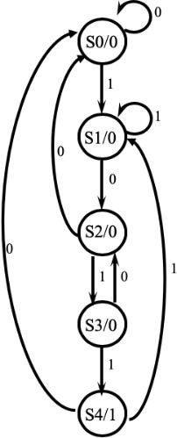

Pre-Requisites:
Xilinx-Vivado

Pre-Lab:
- What is a Moore Sequence Detector, and how does it differ from a Mealy Sequence Detector in digital logic design?

- How does a Moore Sequence Detector operate, and what is its primary function in terms of input and output behavior?

- Can you explain the concept of a state diagram in the context of a Moore Sequence Detector, and how is it used to represent the system's behavior?

- How is the design of a Moore Sequence Detector influenced by the specific sequence it is intended to detect, and what is the role of state transitions in this design?

- In what practical applications are Moore Sequence Detectors commonly used, and what are some advantages and limitations of using them in digital systems?

In-Lab:
Design the parity generator and checker circuit using Verilog HDL.

See the RTL view and understand the logic.

Write test bench and simulate for different inputs and output responses.

Sample VIVA-VOCE Questions (In-Lab):
- What is the primary function of a Moore Sequence Detector in digital systems?
  - To generate sequences of random numbers
  - To detect specific sequences of input symbols
  - To perform arithmetic operations on binary data
  - To encode and decode digital signals

- In a Moore Sequence Detector, where are the outputs associated with a detected sequence produced?
  - At the input stage
  - In combinational logic
  - In the state transitions
  - At the output stage

- How is the operation of a Moore Sequence Detector influenced by the current state?
  - The current state has no impact on the operation.
  - The current state determines the next state and output.
  - The current state is determined by the input sequence.
  - The current state is generated randomly.

- In a Moore Sequence Detector, what is the purpose of the state diagram?
  - To represent the output sequence only
  - To show the input sequence only
  - To illustrate the state transitions and associated outputs
  - To display the input and output sequences simultaneously

- What is a common application of Moore Sequence Detectors?
  - Image processing in cameras
  - Audio signal generation
  - Keypad scanning in electronic devices
  - GPS navigation in smartphones

Post-Lab:
Record the hardware utilised and use any optimization techniques possible.

Record Power dissipation for different technology methods.

Record timing analysis for different technology methods.

Evaluator Remark (if Any): | Marks Secured out of 50
 | Signature of the Evaluator with Date
Evaluator MUST ask Viva-voce prior to signing and posting marks for each experiment.

Experiment Title: Implement Mealy Sequence generator Using Verilog Code.
Aim/Objective:
The aim of this experiment is to Implement Mealy Sequence generator Using Verilog Code.

Description:
A Mealy Sequence Generator is a type of finite state machine (FSM) used in digital electronics to generate a sequence of output values based on both the current state and the current input. In contrast to Moore machines, where the output depends only on the current state, Mealy machines produce output values that are also influenced by the present input. This can lead to more complex, highly flexible sequence generation. Here's a detailed description of a Mealy Sequence Generator:

Key Components of a Mealy Sequence Generator:
- Input Signals: Mealy Sequence Generators take a sequence of binary input signals as their primary input. The sequence can be composed of '0's and '1's.
- State Register: The state register stores the current state of the FSM, much like in Moore machines. It has enough bits to represent the number of states needed to generate the desired sequence.
- State Transition Logic: The state transition logic determines how the FSM transitions from one state to another based on the current state and the input signal. This logic defines the state transition diagram.
- Output Logic: The output logic generates the output signals based on both the current state and the input signal. In a Mealy machine, the output is influenced by both the state and the input, which allows for greater flexibility in generating sequences.

Operation:
- The Mealy Sequence Generator starts in an initial state.
- For each clock cycle, the FSM examines the current input signal and the current state to determine the next state using the state transition logic. The output is also generated based on the current input and state.
- The output signals are updated in real-time and are directly influenced by both the current state and the current input.
- The FSM repeats this process for each input signal in the sequence.

Applications:
Mealy Sequence Generators have various applications, including but not limited to:
- Data Communication and Protocols: They are used to generate specific sequences of output values in data communication, such as generating acknowledgment signals or encoding and decoding data in communication protocols.

- Control Systems: They are used for control and decision-making processes in digital systems, especially in situations where real-time adaptation to inputs is required.
- Digital Signal Processing: They can be used for signal processing applications that require generating output sequences based on both the current state and the input.
- Pattern Recognition and Response: They are employed in applications where the FSM needs to recognize specific patterns in the input and respond accordingly.

Designing a Mealy Sequence Generator involves defining the sequence to be generated, determining the number of states, creating a state transition diagram, and designing the output logic. Mealy machines are particularly useful when the output must react to and depend on the current input values, making them more flexible and adaptive in certain applications.

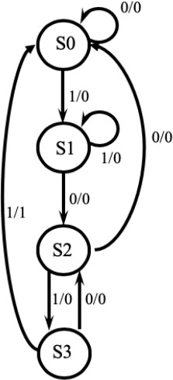

Pre-Requisites:
Xilinx-Vivado

Pre-Lab:
- What is a Mealy Sequence Generator, and how does it differ from a Moore Sequence Generator in digital logic design?

- How does a Mealy Sequence Generator operate, and what is its primary function in terms of input and output behavior?

- Can you explain the concept of state transitions in the context of a Mealy Sequence Generator and how they influence the generation of sequences?

- What is the significance of the combination of current state and input in Mealy machines, and how does it affect the output behavior?

- In what practical applications are Mealy Sequence Generators commonly used, and what are some advantages and limitations of using them in digital systems?

In-Lab:
Design the parity generator and checker circuit using Verilog HDL.

See the RTL view and understand the logic.

Write test bench and simulate for different inputs and output responses.

Sample VIVA-VOCE Questions (In-Lab):
- What is the primary function of a Mealy Sequence Generator in digital systems?
  - To generate random sequences of numbers
  - To detect specific sequences of input symbols
  - To perform arithmetic operations on binary data
  - To encode and decode digital signals

- How does a Mealy Sequence Generator differ from a Moore Sequence Detector?
  - In Mealy machines, the output depends only on the current state.
  - Mealy machines have no outputs associated with state transitions.
  - Mealy machines have no states.
  - Mealy machines do not use combinational logic.

- What is the key feature of a Mealy Sequence Generator in terms of its outputs?
  - The outputs depend only on the current state.
  - The outputs depend on the current state and the input symbols.
  - The outputs are determined solely by the input symbols.
  - The outputs are generated randomly.

- How is the operation of a Mealy Sequence Generator influenced by the input symbols?
  - The input symbols have no impact on the operation.
  - The input symbols determine the next state and output.
  - The input symbols are generated randomly.
  - The input symbols are used to compute the current state.

- In a Mealy Sequence Generator, where are the outputs associated with a detected sequence produced?
  - At the input stage
  - In combinational logic
  - In the state transitions
  - At the output stage

Post-Lab:
Record the hardware utilised and use any optimization techniques possible.

Record Power dissipation for different technology methods.

Record timing analysis for different technology methods.

Evaluator Remark (if Any): | Marks Secured out of 50
 | Signature of the Evaluator with Date
Evaluator MUST ask Viva-voce prior to signing and posting marks for each experiment.

Experiment Title: Design Gated Clock 4-bit Up/down Synchronous and Asynchronous counter using Verilog Code
Aim/Objective:
The aim of this experiment is to Design Gated Clock 4-bit Up/down Synchronous and Asynchronous counter using Verilog Code

Description:
A 4-bit up/down counter is a digital circuit that can count in both the upward (increment) and downward (decrement) directions, depending on the control inputs. These counters are widely used in digital electronics for various applications, including sequencing, address generation, and controlling the operation of digital systems. There are two main types of 4-bit up/down counters: synchronous and asynchronous.

Synchronous 4-bit Up/Down Counter:
Key Characteristics:
- Synchronous Counting: In a synchronous 4-bit up/down counter, all the flip-flops change state simultaneously on the rising edge or falling edge of the clock signal, ensuring synchronized counting.
- Control Inputs: These counters have control inputs, including Up/Down control (U/D), Load (LD), and Clear (CLR). The U/D input determines the counting direction (up or down), LD loads a specific value into the counter, and CLR resets the counter to its initial state.
- Flip-Flops: Four flip-flops (one for each bit) store the counter's current value, and their outputs are connected to create a 4-bit binary count.
Operation:
- When the U/D input is high (up), the counter increments its value on each clock cycle.
- When the U/D input is low (down), the counter decrements its value on each clock cycle.
- The LD input can be used to load a specific value into the counter, and CLR resets the counter to zero.
Applications:
- Digital frequency dividers.
- Sequence generators.
- Digital timers and clocks.
- Address generation in microcontrollers and microprocessors.
Asynchronous 4-bit Up/Down Counter:
Key Characteristics:
- Asynchronous Counting: In an asynchronous 4-bit up/down counter, each flip-flop changes state independently of the others, allowing for more flexible counting sequences.

- Control Inputs: Similar to the synchronous counter, asynchronous counters have control inputs for Up/Down control, Load, and Clear.
- Flip-Flops: Four flip-flops store the counter's current value, and their outputs are connected to create a 4-bit binary count. Unlike synchronous counters, changes in flip-flop states can propagate at different times.
Operation:
- Similar to the synchronous counter, the U/D input determines the counting direction (up or down).
- The LD input can load a specific value into the counter.
- CLR resets the counter to zero.
Applications:
- Pulse width modulators.
- Frequency dividers with more flexible counting sequences.
- Asynchronous counters are generally more suitable for applications where specific counting sequences are required, such as generating non-standard clock frequencies.
In summary, 4-bit up/down counters are versatile digital circuits that can be used in various applications to provide counting, sequencing, and control functionalities. The choice between synchronous and asynchronous counters depends on the specific requirements of the application, with synchronous counters being suitable for most standard counting tasks, and asynchronous counters offering more flexibility in terms of counting sequences.

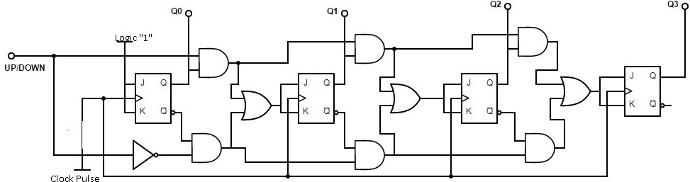

Pre-Requisites:
Xilinx-Vivado

Pre-Lab:
- What is an Up Counter, and how does it differ from a Down Counter in digital circuits?

- Can you explain the concept of a Synchronous Counter and how it operates with respect to clock signals?

- How does an Asynchronous Counter differ from a Synchronous Counter in terms of clocking and state transition?

- What is the significance of counting direction in Up/Down counters, and how is it controlled?

- In what practical applications are Up/Down Synchronous and Asynchronous counters commonly used, and what are their advantages and limitations in various scenarios?

In-Lab:
Design the parity generator and checker circuit using Verilog HDL.

See the RTL view and understand the logic.

Write test bench and simulate for different inputs and output responses.

Sample VIVA-VOCE Questions (In-Lab):
- What is the primary function of an up counter in digital circuits?
  - To count upwards in a sequence
  - To count downwards in a sequence
  - To count in both upward and downward directions
  - To store data temporarily

- In a synchronous counter, when does all the flip-flops change their state simultaneously?
  - At the rising edge of the clock signal
  - At the falling edge of the clock signal
  - Whenever an input is applied
  - In a random order

- What is the primary purpose of an up/down counter?
  - To count upwards only
  - To count downwards only
  - To count in both upward and downward directions
  - To store configuration data

- In an asynchronous counter, how do the flip-flops change their state?
  - Simultaneously at a clock edge
  - Sequentially, one after the other
  - In response to external input signals
  - Randomly

- What is the significance of counting direction in up/down counters, and how is it controlled?
  - Counting direction determines the clock frequency.
  - Counting direction controls the number of flip-flops used.
  - Counting direction determines whether the counter counts up or down.
  - Counting direction has no impact on counter operation.

Post-Lab:
Record the hardware utilised and use any optimization techniques possible.

Record Power dissipation for different technology methods.

Record timing analysis for different technology methods.

Evaluator Remark (if Any): | Marks Secured out of 50
 | Signature of the Evaluator with Date
Evaluator MUST ask Viva-voce prior to signing and posting marks for each experiment.

Experiment Title: Design 3-bit Random number generator using Verilog Code
Aim/Objective:
The aim of this experiment is to Design 3-bit Random number generator using Verilog Code

Description:
A random number generator (RNG) is a computational or physical device that generates a sequence of numbers or values that lack any discernible pattern and appear to be statistically random. Random number generators are widely used in various fields, including computer science, cryptography, gaming, simulations, and statistics, where unpredictability and randomness are essential. Here's a description of random number generators:

Types of Random Number Generators:
- Pseudo-Random Number Generators (PRNGs): These are deterministic algorithms that produce sequences of numbers that appear random but are generated using a starting value called a seed. PRNGs are widely used in computer applications, including games, simulations, and cryptographic systems. Common PRNG algorithms include the Linear Congruential Generator (LCG) and the Mersenne Twister.
- True Random Number Generators (TRNGs): TRNGs rely on physical processes or phenomena to generate truly random values. Examples of TRNG sources include electronic noise, radioactive decay, atmospheric noise, and even mouse movements. TRNGs are considered more suitable for cryptographic applications due to their inherent unpredictability.

Key Characteristics and Features:
- Statistical Properties: Good random number generators exhibit a uniform distribution, meaning that each possible value has an equal chance of being generated. They also have low correlation between successive numbers, and they pass various statistical tests for randomness.
- Seed Value: PRNGs require an initial seed value to start generating random numbers. The same seed will produce the same sequence of random values, making PRNGs predictable if the seed is known.
- Periodicity: PRNGs have a finite sequence or period, after which they start repeating the sequence. The length of the period depends on the specific PRNG algorithm and the size of the seed.
- Entropy: TRNGs generate random values based on unpredictable physical processes, such as electronic noise. They are considered to have higher entropy than PRNGs, making them suitable for cryptographic applications.

Applications:
Random number generators are used in a wide range of applications, including:
- Cryptography: Cryptographic protocols and systems rely on random numbers for key generation, initialization vectors, and digital signatures. TRNGs are often preferred for cryptographic applications.
- Gaming: Video games use random numbers for various purposes, including character behavior, game events, and procedural content generation.
- Simulations: In scientific simulations, random numbers are used to model uncertain or stochastic processes, such as weather simulations or Monte Carlo simulations in finance.
- Security: Random numbers are used in security protocols to provide challenge-response mechanisms and protect against attacks like replay attacks.
- Statistical Sampling: Random numbers are essential for random sampling in statistical studies, quality control, and polling.
- Random Testing: In software testing, random number generators can be used to create test cases with unexpected inputs to uncover software vulnerabilities.
- Artificial Intelligence: Random numbers can be used in AI algorithms for various purposes, including exploration in reinforcement learning.
- Noise Generation: In audio and visual applications, random numbers can be used to generate natural-looking noise, such as in image processing and audio effects.

Random number generators play a critical role in a wide array of applications, making them an essential component in digital systems and computer science. The choice between PRNGs and TRNGs depends on the specific requirements of the application, with TRNGs being favored when high unpredictability and security are paramount.
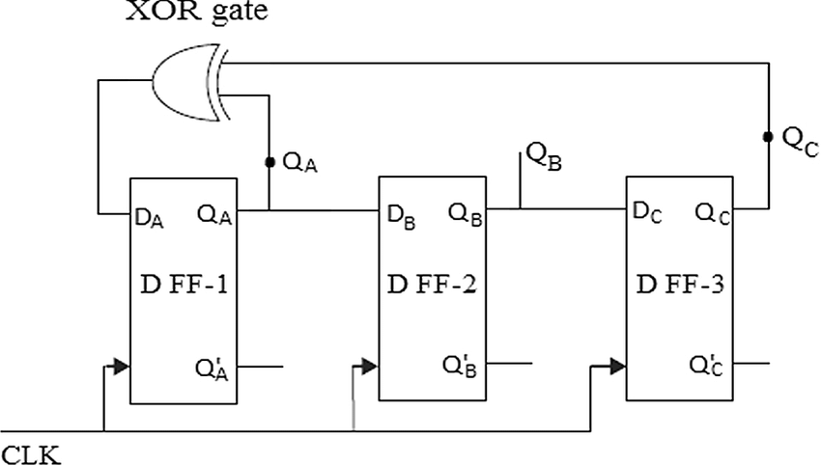

Pre-Requisites:
Xilinx-Vivado

Pre-Lab:
- What is a Random Number Generator (RNG), and how does it produce random or pseudorandom numbers in digital systems?

- Can you explain the difference between true random number generators and pseudorandom number generators, and the scenarios where each is most suitable?

- What are the key characteristics and properties that define the quality and randomness of numbers generated by an RNG?

- How is the unpredictability and statistical properties of random numbers evaluated, and what are common tests and measures for assessing the quality of RNGs?

- In what practical applications are Random Number Generators commonly used, and what are the security and reliability considerations associated with their use, especially in cryptography and gaming?

In-Lab:
Design the parity generator and checker circuit using Verilog HDL.

See the RTL view and understand the logic.

Write test bench and simulate for different inputs and output responses.

Sample VIVA-VOCE Questions (In-Lab):
- What is the primary purpose of a Random Number Generator (RNG) in digital systems?
  - To generate truly random numbers for cryptographic applications
  - To produce pseudorandom numbers for simulation and gaming
  - To perform arithmetic operations on binary data
  - To store and retrieve data in memory

- What is the main difference between a true random number generator (TRNG) and a pseudorandom number generator (PRNG)?
  - TRNGs are deterministic, while PRNGs produce truly random numbers.
  - TRNGs rely on external physical processes, while PRNGs use algorithms.
  - TRNGs are faster than PRNGs.
  - PRNGs are used for secure cryptographic applications.

- What characteristic is commonly used to evaluate the quality of random numbers generated by an RNG?
  - Speed of generation
  - Entropy
  - Pseudorandomness
  - Deterministic pattern

- In cryptography, why is the quality of random numbers crucial in applications like encryption and key generation?
  - High-quality random numbers lead to faster encryption.
  - Low-quality random numbers provide stronger security.
  - Low-quality random numbers can compromise security.
  - Random numbers have no relevance in cryptography.

- In what practical applications are Random Number Generators commonly used, aside from gaming and simulations?
  - Manufacturing and assembly line automation
  - Weather forecasting and climate modeling
  - Cryptographic systems, secure communication, and secure key generation
  - Medical diagnostics and drug development

Post-Lab:
Record the hardware utilised and use any optimization techniques possible.

Record Power dissipation for different technology methods.

Record timing analysis for different technology methods.

Evaluator Remark (if Any): | Marks Secured out of 50
 | Signature of the Evaluator with Date
Evaluator MUST ask Viva-voce prior to signing and posting marks for each experiment.

Experiment Title: Implement SRAM using Verilog Code
Aim/Objective:
The aim of this experiment is to Implement SRAM using Verilog Code

Description:
SRAM, or Static Random-Access Memory, is a type of semiconductor memory that provides high- speed data storage and retrieval capabilities. Unlike dynamic RAM (DRAM), SRAM does not require periodic refreshing to maintain data integrity, which makes it faster and more suitable for specific applications where speed and low power consumption are crucial. Here is a description of SRAM:

Key Characteristics and Features of SRAM:
- Volatile Memory: SRAM is a volatile memory technology, which means that data stored in SRAM is retained only as long as power is supplied. When power is removed, the data is lost.
- Speed: SRAM is known for its speed and low latency. It offers fast access times, making it suitable for high-performance applications, including cache memory in microprocessors.
- Stability: SRAM is "static" in nature, meaning it stores data using flip-flops or latches, which retain their state as long as power is applied. This is in contrast to dynamic RAM (DRAM), which uses capacitors and requires periodic refreshing to maintain data integrity.
- Read-Write Access: SRAM provides symmetric read and write access times. Data can be read from and written to SRAM with equal ease.
- Cell Structure: SRAM cells are typically constructed using cross-coupled inverters (a flip-flop) to store a single bit of data. Each cell comprises six transistors, which is more complex and larger than the cell structure of DRAM.
- Low Power Consumption in Standby: When not actively reading from or writing to SRAM, it consumes very little power, making it an energy-efficient choice for applications where power efficiency is important.
- No Refresh Required: Unlike DRAM, SRAM does not require periodic refreshing to maintain data integrity. Data remains stable as long as power is supplied.

Applications:
SRAM is used in various applications, including:
- Cache Memory: SRAM is commonly used as cache memory in microprocessors to provide high-speed access to frequently used data and instructions.
- Embedded Systems: It is used in embedded systems, such as microcontrollers and FPGAs, where speed and low power consumption are essential.
- Networking Equipment: SRAM is used in networking devices like routers and switches to store routing tables and buffers.
- Graphics Cards: In high-performance graphics processing units (GPUs), SRAM is used for storing textures and frame buffers.

- Real-Time Systems: In real-time systems, such as automotive control units, SRAM provides fast access to critical data.
- Battery-Powered Devices: SRAM's low power consumption in standby mode makes it suitable for battery-powered devices, including mobile phones and IoT devices.
- Processor Registers: It is used in processor registers for fast data access during arithmetic and logic operations.

SRAM's primary advantage is its speed and simplicity, making it well-suited for applications that require fast, low-latency data storage. However, it is typically more expensive and less dense than DRAM, so it is often used in combination with DRAM in systems to strike a balance between performance and cost.

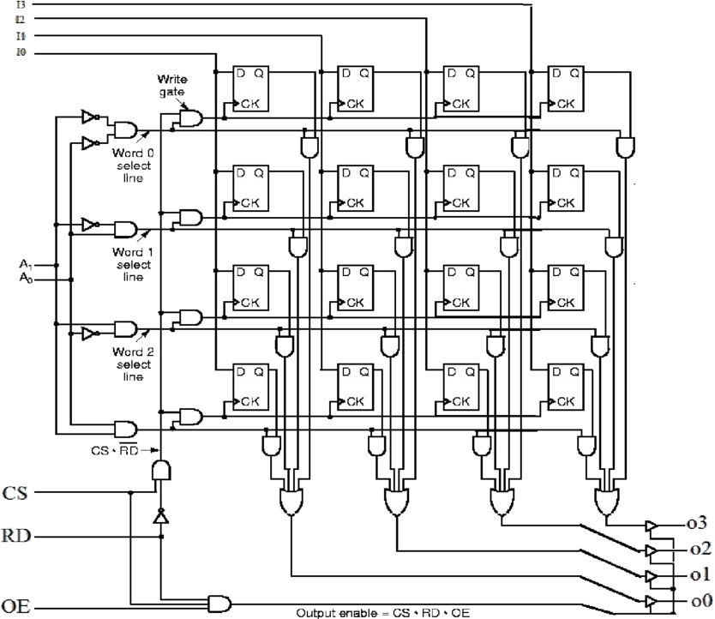

Pre-Requisites:
Xilinx-Vivado

Pre-Lab:
- What is SRAM, and how does it differ from Dynamic Random-Access Memory (DRAM) in terms of data storage and access?

- How does SRAM store data, and what is the significance of its static nature in contrast to dynamic memory technologies?

- What are the key advantages of SRAM, such as speed, power efficiency, and resistance to data loss, in comparison to other memory types?

- Can you explain the concept of a flip-flop in the context of SRAM and how it enables the storage and retrieval of data?

- In what applications and scenarios is SRAM commonly used, and what are some of its limitations and challenges in terms of cost and density compared to other memory technologies like NAND Flash?

In-Lab:
Design the parity generator and checker circuit using Verilog HDL.

See the RTL view and understand the logic.

Write test bench and simulate for different inputs and output responses.

Sample VIVA-VOCE Questions (In-Lab):
- What is the primary function of Static Random-Access Memory (SRAM) in digital systems?
  - To store data permanently
  - To store and retrieve data quickly and temporarily
  - To perform arithmetic operations
  - To amplify analog signals

- How does SRAM differ from Dynamic Random-Access Memory (DRAM) in terms of data storage?
  - SRAM uses capacitors to store data, while DRAM uses flip-flops.
  - SRAM is volatile, while DRAM is non-volatile.
  - SRAM requires constant refreshing, while DRAM does not.
  - SRAM is slower than DRAM.

- What is the primary advantage of SRAM over DRAM?
  - SRAM is more cost-effective.
  - SRAM is non-volatile.
  - SRAM is faster and doesn't require periodic refreshing.
  - SRAM is used for long-term data storage.

- In a typical SRAM cell, how many transistors are used to store one bit of data?
a) 1
b) 2
c) 4
d) 8

- In what applications is SRAM commonly used?
  - Long-term data storage in hard drives
  - Temporary data storage in CPU caches
  - Audio and video processing
  - High-capacity data centers

Post-Lab:
Record the hardware utilised and use any optimization techniques possible.

Record Power dissipation for different technology methods.

Record timing analysis for different technology methods.

Evaluator Remark (if Any): | Marks Secured out of 50
 | Signature of the Evaluator with Date
Evaluator MUST ask Viva-voce prior to signing and posting marks for each experiment.

